# Team Members:

**CIS 641 01 - IP - Systems Analysis and Design (F24)**

* Likitha Magham
* Swethasarayu Simhadri
* Bhavana Arla

# Class Diagram:

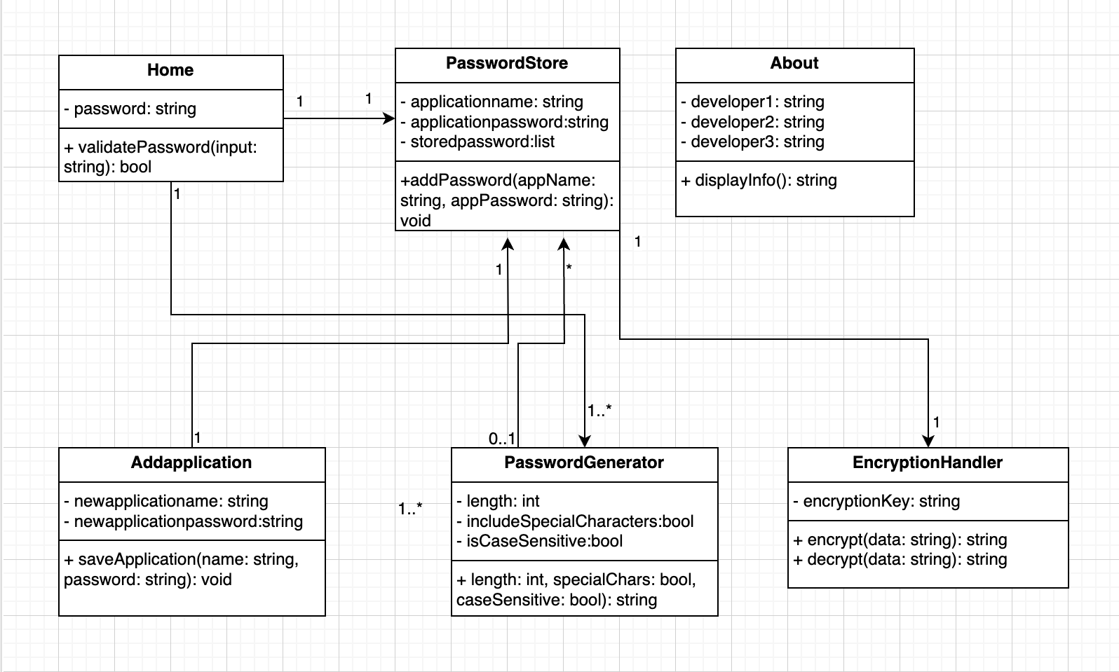

1. **Home**

**Description**: This class represents the main entry point for the application where users validate their passwords to access the system.

# Methods:

* + validatePassword(input: string): bool
    - Preconditions: A user must provide a valid password.
    - Postconditions: Returns true if the password matches, granting access to the system.

# PasswordStore

**Description**: This class is responsible for storing and managing passwords for different applications.

# Attributes:

* + applicationname: string – The name of the application.
  + applicationpassword: string – The password associated with the application.
  + storedpassword: list – A collection of all stored application passwords.

# Methods:

* + addPassword(appName: string, appPassword: string): void
    - Preconditions: Application name and password must be provided.
    - Postconditions: Saves the application's password in the storedpassword list.

# Addapplication

Description: This class handles adding new applications and their associated passwords to the password store.

# Attributes:

* + newapplicationname: string – The name of the new application to add.
  + newapplicationpassword: string – The password for the new application.

# Methods:

* + saveApplication(name: string, password: string): void
    - Preconditions: The application name and password must be provided.
    - Postconditions: Adds the application details to the password store.

# PasswordGenerator

**Description**: Responsible for generating secure passwords based on user-defined criteria.

# Attributes:

* + length: int – The desired length of the generated password.
  + includeSpecialCharacters: bool – Whether to include special characters in the password.
  + isCaseSensitive: bool – Whether the password should include both uppercase and lowercase letters.

# Methods:

* + length, specialChars, caseSensitive: bool): string
    - Preconditions: User must specify the required password criteria (length, special characters, case sensitivity).
    - Postconditions: Generates a secure password that matches the given criteria.

# EncryptionHandler

**Description**: This class provides functionality for encrypting and decrypting sensitive data.

# Attributes:

* + encryptionKey: string – The key used for encryption and decryption.

# Methods:

* + encrypt(data: string): string
    - Preconditions: A valid encryption key must be set.
    - Postconditions: Returns the encrypted version of the input data.
  + decrypt(data: string): string
    - Preconditions: Encrypted data and a valid encryption key must be provided.
    - Postconditions: Returns the decrypted version of the input data.

# About

**Description**: This class provides information about the developers of the application.

# Attributes:

* + developer1: string – Name of the first developer.
  + developer2: string – Name of the second developer.
  + developer3: string – Name of the third developer.

# Methods:

* + displayInfo(): string
    - Preconditions: The application must have developer information available.
    - Postconditions: Displays the names of the developers.